Lab 3

By Hoda Malak
Open “sample super store.xls”
• Click on “Orders” and then “Sheet1”.
• Sheet1:
• Pick up “Sales” and drop it in Rows.
• Drag “Category” and drop it in Columns
• The created bars are not sorted properly.
• Sheet1(Cntd):
• Simply click on “Sales”, to see small lines.
• Click on them to sort amount of sales per category in descending or ascending order
• Swap the fields from their place to have “Sales” on columns and “Category” on rows by clicking on the “swap rows and columns” icon on top or “ctrl+W”.
• Click on small lines next to “Sales” to get sorted.
Q1: Which category has the maximum amount of sales done? And how much?
The category with the maximum amount of sales is the technology category. The total amount of sales for the technology category is 3,514,982.
• Sheet1(Cntd):
• Drag and drop “Sub-Category” next to “Category”
• If you want to sort “Sales” per each category, click on “SUM(Sales)” and then click on “Sort ascending” or “Sort descending” icons on top.
• Swap rows and columns again.
• Click on arrow next to “Category” and select “Sort”, then assign “field” to “Sort By” and select “Ascending”.
• Keep “Sum” in Aggregation
• Then all “Categories” get sorted in ascending order based on their total amount of sales.
Q2: Provide a snapshot of sheet1.
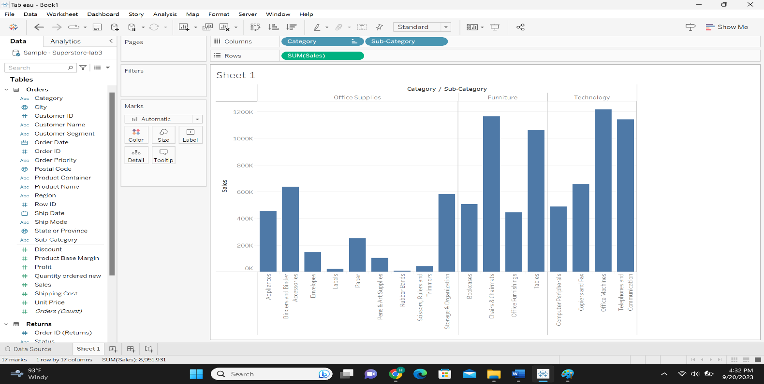
• Sheet1(Cntd):
• If you want to sort the amount of sales of sub-categories within each category
• Select arrow next to “Sub-Category” and select sort. Then assign “Field” to “Sort by”, select “Ascending” and assign “Sales” to Field and keep “Sum” for aggregation, then click ok.
• Afterwards, not only the categories are sorted based on the total amount of sales, but also the sub-categories become sorted within their category based on their sales.
• Drag “Sales” and drop it in “Label” spot within “Marks”
• Labels can show us the exact amount of sales.
Q3: Which subcategory in “Furniture” category has the lowest amount of sales? How much is it?
The office furnishings subcategory has the lowest amount of sales in furniture category. The amount of sale of office furnishings is 444,624.
• Sheet1(Cntd):
• Click on the arrow key next no “sub-category” and select “Clear Sort”. Do the same for “Category” to remove sorting.
• Click on the “clear Sheet” on top.
• Sheet2:
• Assign the “Sales” to Columns, and “Sub-Category” to Rows.
• Click on arrow key next to “Sub-category” and select “Sort”. Then assign “field” to “Sort By”, “Profit” to “Field Name”,
and “Sum” to “Aggregation”.
• Swap the fields.
• Then drag and drop “Profit” to the label.
• Now all “Sub-Category” items become sorted based on the “Profit” in an ascending order.
• Then drag “Profit” to the “Label” spot in Marks, to see how sub-categories are sorted based on the amount of profit.
Meanwhile, each bar display the amount of total sales in each sub-category.
• Mark demonstrates sorting based on Color, Size, Label and so on. Drag and drop “Profit” into “Color” inside “Marks”.
Afterwards, blue color is assigned to the highest “Profit” and yellow color is assigned to the lowest “profit”.
• Then, select “Sum(Profit)” and click on two ascending or descending options on top.
Q4: Which subcategory has the most amount of profit? How much is it?
The subcategory that has the most amount of profit is telephone and communication, and the profit of this subcategory is 297,951.
Q5: Provide a snapshot of sheet2.
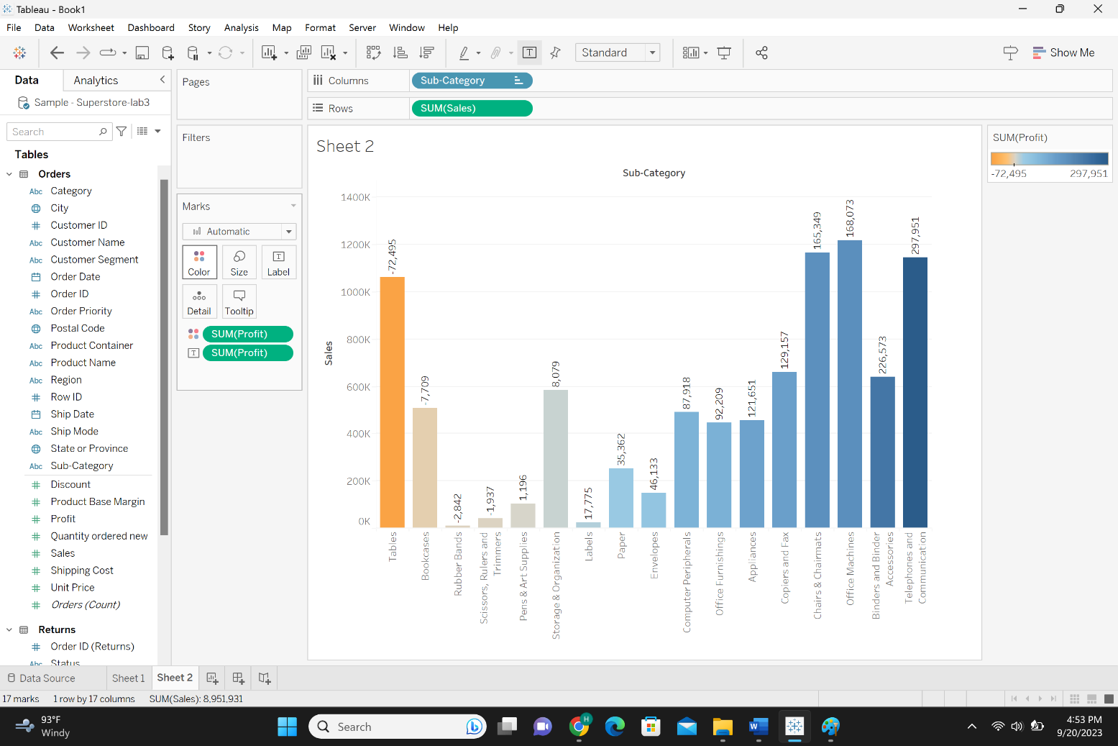
• Sheet3:
• Drag and drop “Sales” in Columns and “Region” in Rows
• If you want to compare sales done in one region with all other
regions you have to make a group
• If you want to compare sales done in “Central” with other regions,
you have to combine “East”, “South” and ”West” into one group.
• Select the first header (East) and “Ctrl+Click” then select the next
headers (South and , then right click and select “Group”
• Alternative option is click on “Group Member” icon on top
• Then the “region(Group)” is created within the “Dimension”,
which has the heading named as the combination names of
previous headers
• Now we can easily compare the sales done in central with other
regions
• So, if you combine the data, a separate dimension will be created.
• Clear your sheet.
• Sheet4:
• Assign “Sales” to Columns and “Sub-category” to Rows.
• We want to combine five top sub-categories into one group and compare it with other
elements.
• Click on “sub-category” drop down on “Dimensions”, click on “create group”
• On the window, click five different elements by “Ctrl+click” and then select “group”
• The name of the group will be by default the combination of all names, change it into
“Small Office Appliances” if you want to add more elements to this group, click on the
element and from “Add to” select “Small Office Appliances”.
• Keep the name of the Field as it is “Sub-Category (group)”
• Then “apply” and “ok”.
• Now remove “Sub-Category” from “Rows” and drag “Sub-Category (group)” in Rows.
• Now it is clear that the “sales” done in “Small Office Appliances” is the highest
compared to the other elements.
Q6: Provide a snapshot of sheet4.
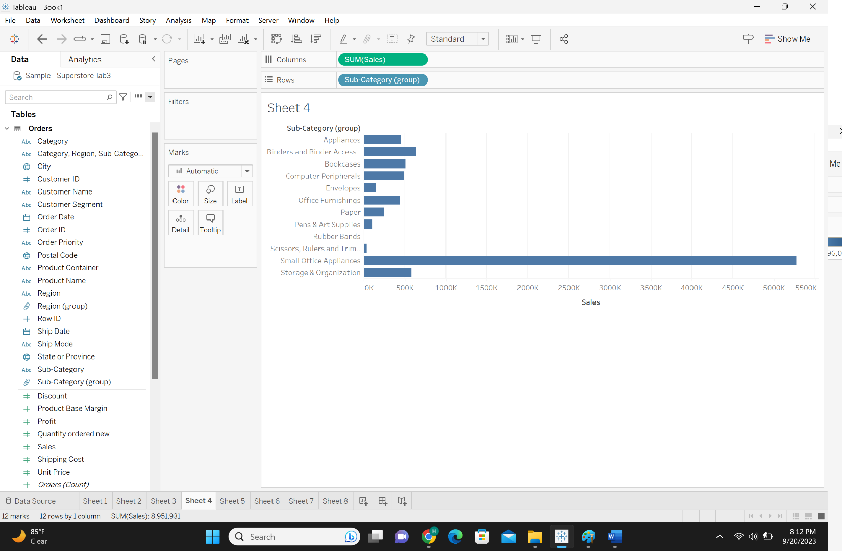
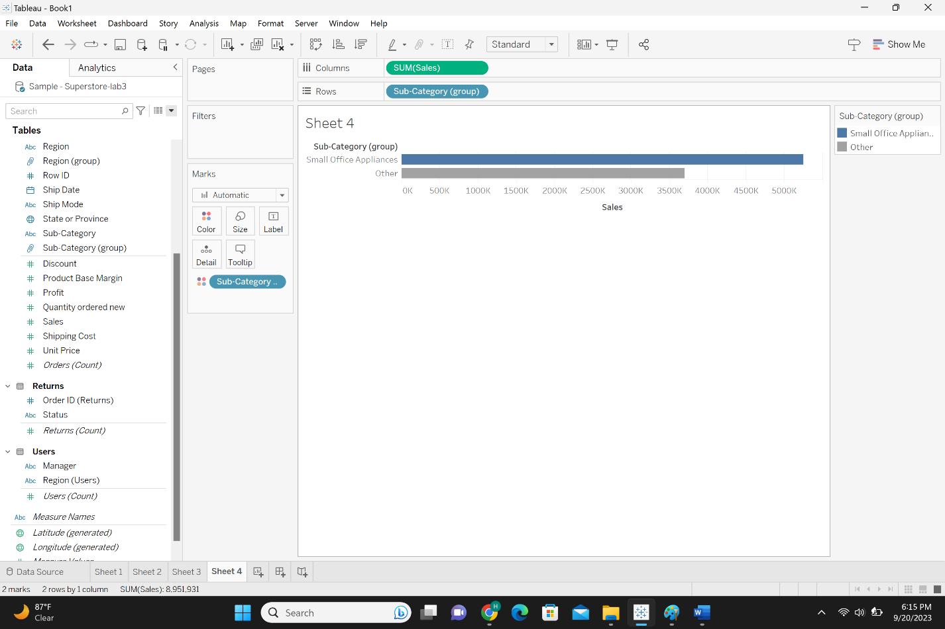
• If you want to edit group, right click on the “Sub-Category (group)” in “Dimnsions”
and select “Edit Group”
• If you want to find an item such as “label”, write it in the “find” box, then click on it
and select drop down of “Add to:” and select “Small Office Appliances” and then “ok”.
• Clear your sheet.
Sheet5:
• First, create “Products” hierarchy which contains “Category” and “Sub-
Category”, as taught before.
• We already created “Sub-Category (group)”, what if we want to use this
rather than “Sub-Category” in “Products” hierarchy
• So drag and drop “Sub-Category (group)” inside the “Products”
• Then remove “Sub-Category” and keep only “Sub-Category (group)”
• Clean your sheet.
• Sheet6:
• Drag “Products” and drop it in “Columns” and drag “Sales” and drop it in
“Rows”. Expand the plus sign next to “Category” in Rows”.
• Drag and drop “Profit” in “Color” Marks.
• Then you could infer that the amount of “Sales” done in “Small Office
Appliances” is the highest compared to other elements in all the
“Categories”. While in some “Categories”, it does not make the most
“Profit”.
• If you do not want the hierarchy, you can easily remove it from the
“Dimensions”.
• Clean your sheet.
• Sheet7:
• If there are some graphs, charts, scatter-charts, you can group elements into one part.
• Assign “Profit” to “Columns” and “Shipping Cost” to “Rows”, click on their drop down and select measure, average.
• Drag and drop “Sub-Category” to the “Color” Marks.
• Each color resembles each “Sub-Category”.
• We want to group “Categories” in one place.
• Make a box using the mouse on the screen.
• Then click on the “ Group Members” icon and select “Sub-Category”.
• Then we will have “appliances, binders,...” and “Others” under “Sub-Category”.
Q7: Provide a snapshot of sheet7.
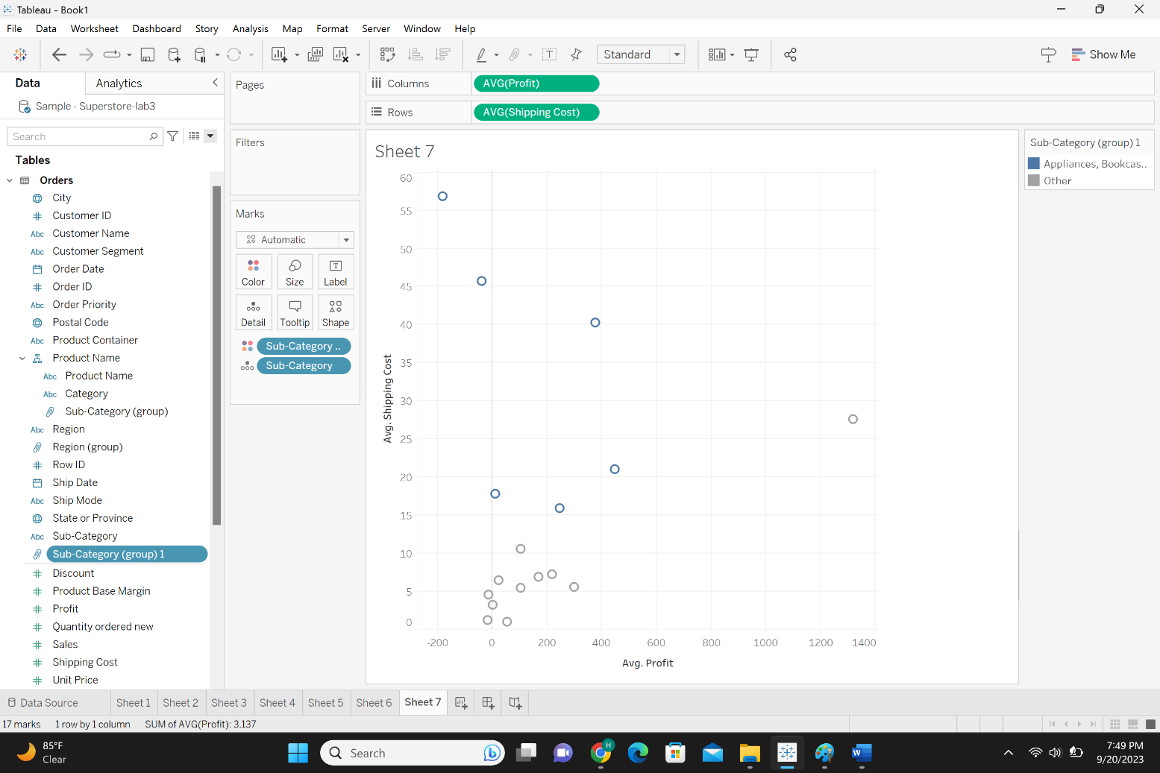
• Combine is used to combine two or more dimensions together,
then we can analyze the data better.
• Sheet 8:
• Drop ‘Category’ and “Sub-Category” in Rows and drop ‘Sales’ in
Text spot.
• Then in the table, sum of sales done in each sub-category will be
displayed.
• If you want to find out the highest sales done in category and
sub-category done. Select “SUM(Sales)” and then sort it in
descending order.
• The resultant table shows the sales done in descending order in
that particular category.
• If you want to see the highest sales in both combinations, the
combine method would be helpful. So, we need to combine
‘Category’ and ‘Sub-Category’ and create third dimension rather
then two separate dimensions.
Whatever fields you want to combine, select the first
(Category) and second one (Sub-Category) dimensions in
‘Dimensions’, then select drop down and select create
“Combined Field”. Afterwards, the new field named
combination of two fields (Sub-Category & Category
(Combined)) in Dimensions is created.
• Drop “Sub-Category & Category (Combined)” in Rows,
which then shows Category along with Sub-Category.
• In order to see the ‘Sales’, drop ‘Sales’ in Text spot.
• Then, select “Sum(Sales)” and sort it in descending order,
afterwards the highest sales will be shown on top along
with their corresponding ‘Category’ and ‘Sub-Category’.
• Therefore, you can combine two or more fields and work
with it.
• Sheet 9:
• Drop ‘Category’ and ‘Sub-category’ in Rows and ‘Region’ in Columns, and
Sales in Text spot.
• If you want to know the highest sales (in ‘Category’ and ‘Sub-Category’)
with respect to ‘Regions’ is more complicated.
• Pick up ‘Sales’ and drop it in ‘Label’ and ‘Color‘ spots. Using the color
gradient, we can find out the highest sales, which are shown in dark blue
color. There are many sales with dark blue color, which makes it difficult to
find out easily which are the top one. Thus we can use the combine
method, to combine, ‘Region’, ’Category’, and ‘Sub-Category’ fields.
• Select ‘Region’, ‘Category’, and ‘Sub-Category (using Ctrl key), click on the
drop down and select create Combined Field. Afterwards the new field
named “Region, Category, Sub-Category (Combined)” is created. Pick it up
and drop it in Rows, then drop ‘Sales’ in Text.
• Then select ‘SUM(Sales)’ and sort it in descending order, which shows the
highest Sales on top.
Q8: Provide a snapshot of sheet9.


